**Box plot and scatter plot in R**

1. Write down two ways to set the range of an axis in a plot.

#Loading gcookbook to use existing dataframes

install.packages("gcookbook") library(gcookbook)

#Load ggplot2 to plot graphs install.packages("ggplot2") library(ggplot2)

* 1. use xlim() or ylim() to set the minimum and maximum values of a continuous axis.
  2. #ylim() is shorthand for setting the limits with scale_y_continuous()
  3. #using ylim() and scale_y_continuous() together only the second directive has any effect

a)

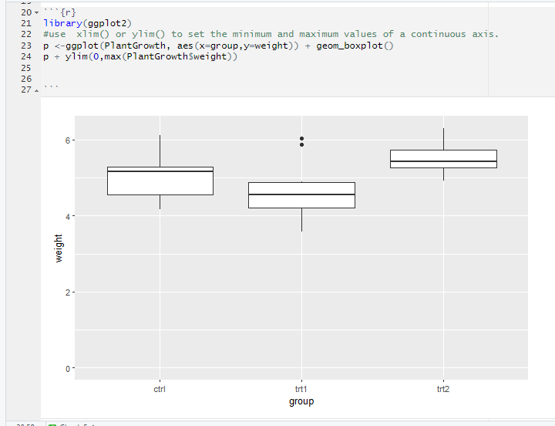

b)

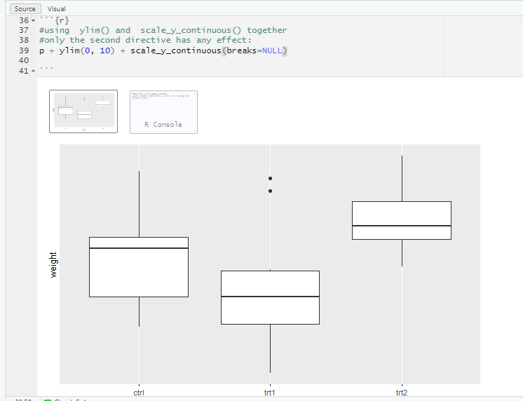

C)

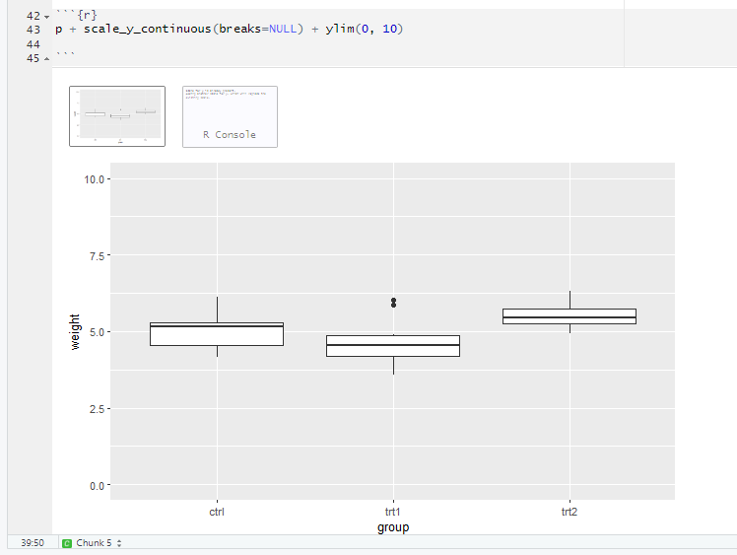

1. Use the mtcars data frame to draw four graphs, respectively. Write down the used functions in ggplot2

(a)

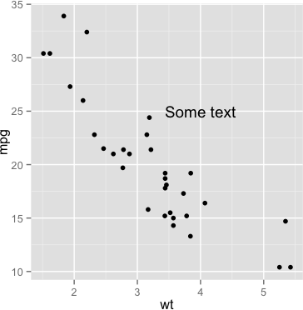



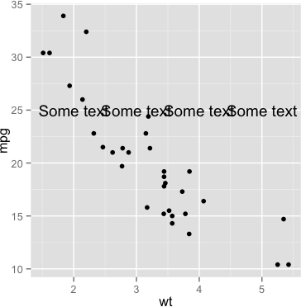(b)

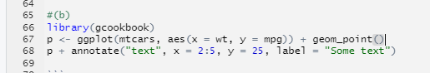

(c)

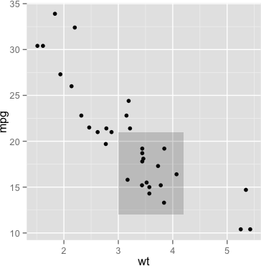

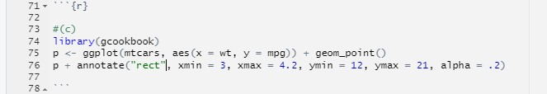

(d)

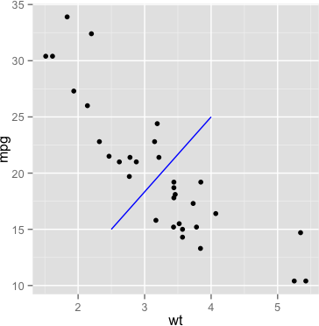

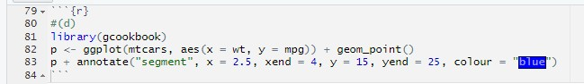

(e)

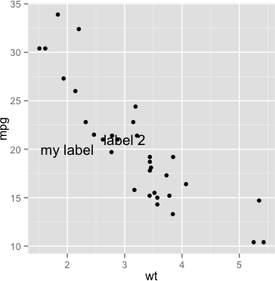

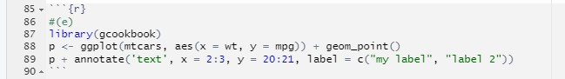

1. Use data frame PlantGrowth and write functions to draw graphs, respectively. (30 points) (a)

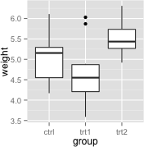

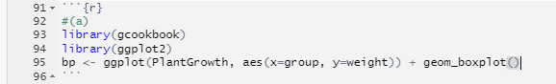

(b)

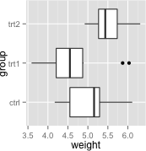

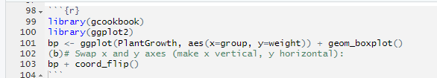

(c)

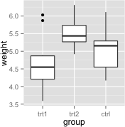

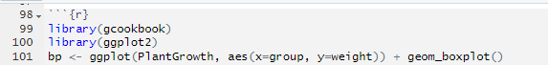



(d)

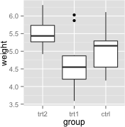

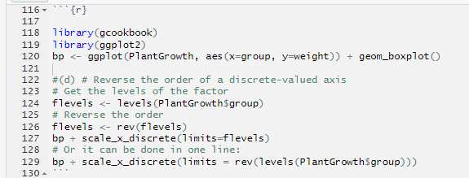

1. Following the same data frame PlantGrowth, and use and write functions to draw the following graphs, respectively.

(a)

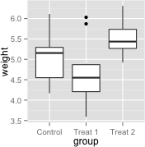

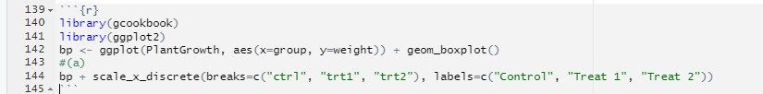

(b)

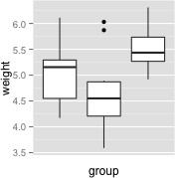

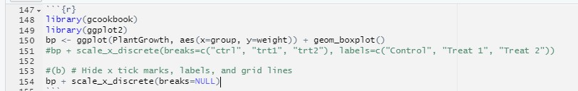

(c)

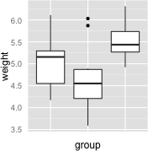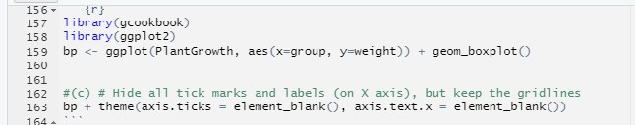

1. Following the same data frame PlantGrowth, and use and write functions to draw the following graphs, respectively.

(a)

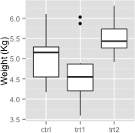

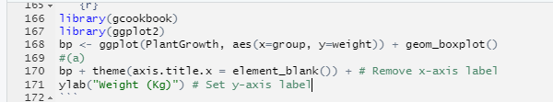

(b)

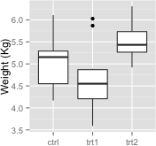

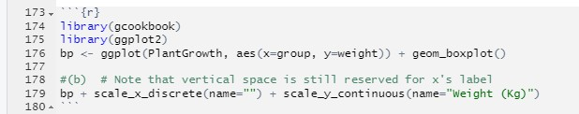

(c) You can use any size and color for the text.

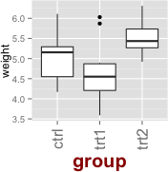

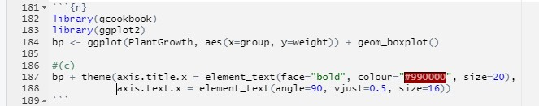

=================================THE END==================================